Name____________________________
7th grade Home & Career Skills
Mrs. Cislo
KITCHEN EQUIPMENT / TOOLS

Name Definition or use
- 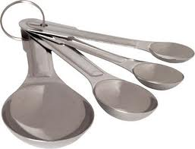 |  | To measure small amounts of liquid, dry and solid ingredients.  Examples:____________________,  & ______________________________.
- 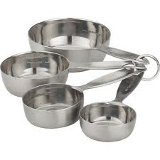 |  | To measure  dry Ingredients.  Examples: _________________&  ______________________________.
- 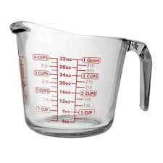 |  | To measure  liquid Ingredients.  Examples: _________________  &___________________________.
- 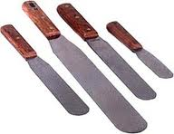 |  | Used with baked goods. Can lift foods out of a pan. Frost a cake or get brownies out of a pan.
- 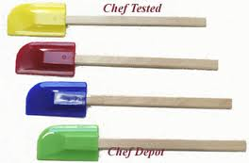 |  | Used scrape batter out of a bowl.
- 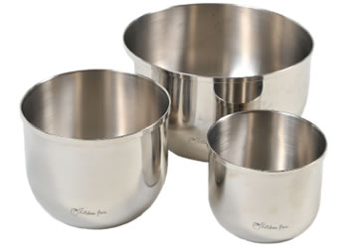 |  | Used to hold ingredients.  Many sizes available.
7. 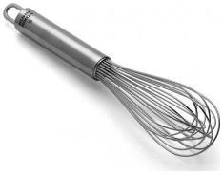 |  | Use to beat ingredients to incorporate air or help mix lumpy batter or sauces.

Name Definition or use
8. 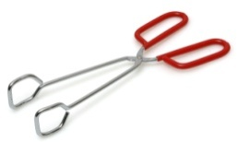 |  | Used to toss or lift foods. Examples include toss a salad or lift corn and the cob.
9. 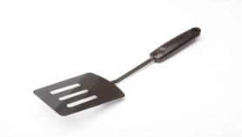 |  | Used to turn or lift foods.  Examples: pancakes or a grilled cheese sandwich
10. 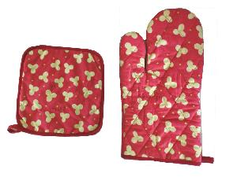 |  | Used to protect your hands from hot pots and pans.
11. 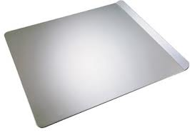 |  | Used to hold cookies while baking. Has one or two raised edges, the rest are flat.
12. 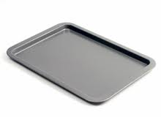 |  | Used to make a jelly roll. Many household use this as their “cookie sheet”. Has 4 raised edges.
13. 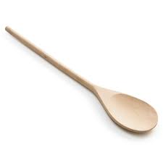 |  | Used to stir hot or cold ingredients.
14.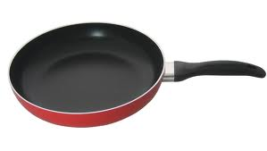 |  | Used to cook or fry foods.
15. 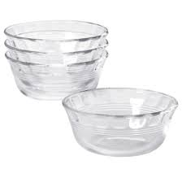 |  | Used to hold small amount of ingredients.
16. 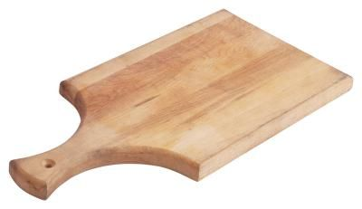 |  | Used when cutting foods to protect your counters and table surfaces. May be made of wood, plastic or glass.
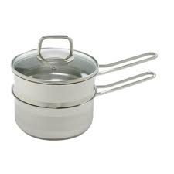  17. |  | Used to melt chocolate. The bottom pot holds warm water and the top pot hold chocolate. Prevents chocolate from burning.

